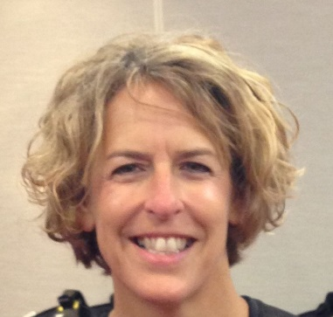
Cheryl Cepelak, MSOL, IPMA-CS

Public Service

Beginning in 1988, Cheryl Cepelak's career with the State of Connecticut has seen her expertise utilized in a number of important assignments with several different agencies. She has served with the Department of Administrative Services, the University of Connecticut Health Center in Organization and Staff Development (OSD), the Department of Correction; the Director of a newly formed Joint Operations Team at the Department of Public Health and currently at the Dept. of Aging and Disability Services.

Practice

Cheryl has extensive experience in the areas of performance management, coaching, facilitation, strategic planning and change management. She has taught numerous classes in these areas, notably instructing for International Public Management Association for Human Resource professionals (IPMA-HR), Managing Employee Performance as a Human Resources Business Partner; CT’s Aspiring Leaders program, Strategic Planning and MBTI classes; along with consulting and facilitating leadership and strategic planning sessions.

Education / Volunteerism

Director Cepelak earned a Bachelor of Science degree from the University of Connecticut in 1986 and a Master of Science in Organizational Leadership from Quinnipiac University in 2012. She has also completed the Quality Management Certificate and Project Management Programs at the Rensselaer Institute at Hartford. She has experience using the Malcolm Baldrige Criteria for Performance Excellence and is certified by Career Systems International to facilitate career development, coaching skills and retention strategy workshops. She has also achieved the qualifications necessary to administer the Myers-Briggs Type Indicator.

Cheryl has been a member of the International Public Management Association for Human Resource professionals (IPMA-HR) since 1999 and in 2007, received the IPMA-HR designation, Certified Specialist, Organizational & Employee Development and recently completed her term the President in 2020.

